Practices for Lesson 4: Accessing Siebel Applications

Practices for Lesson 4

Overview

In these practices, we will learn to access a deployed Siebel application via the Oracle Cloud Infrastructure.

Practice 4-1: Accessing Siebel Applications

**Overview**

In the practice, we will explore Siebel Tools, setup repositories, customizing Scripts and getting the Developer Environment.

**Note:**

You require a public IP Address (to be given to you by facilitator)

The default port number is 4430

There are 3 URLs which are required to be validated for accessing the application which will be validated in this activity.

Assumptions

You should have completed the Practices of Lesson 3.

Tasks

Accessing Siebel Sales Application

1. Open the browser and browse the link (https://<ip-address>:4430/siebel/app/sales/enu) to access the Sales application.
2. Enter the User ID as **SADMIN** and password as **Welcome1** and click **Login** to login into the Sales Application as shown below.

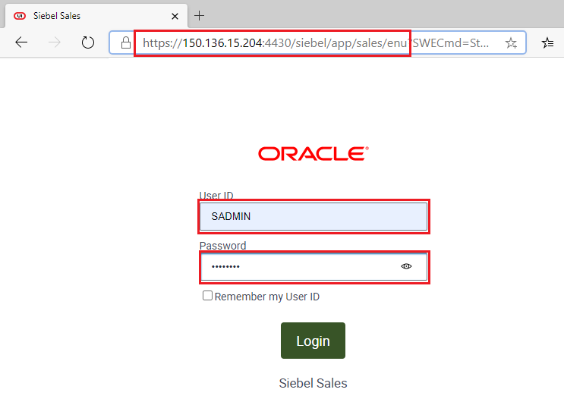

1. You have successfully logged into the sales application as shown below.

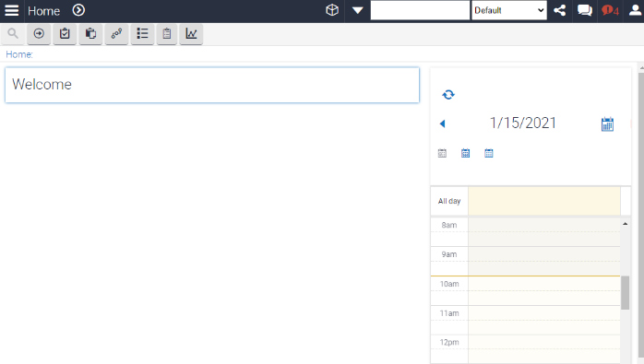

**Access the Siebel web tools**

1. To access the Siebel web tools, browse the link - https://<IP-address>:4430/Siebel/app/webtools/enu.
2. Enter the User ID as **SADMIN** and Password as **Welcome1** and click **Login** to login to the webtools as shown below.

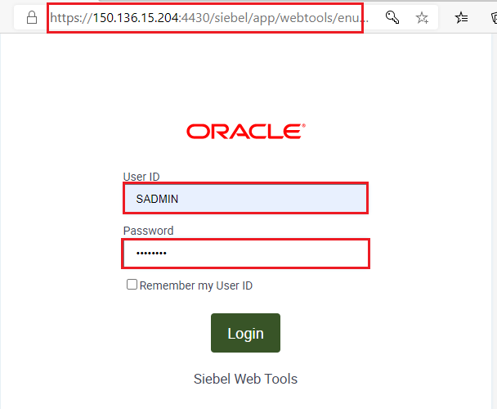

1. You have successfully logged into the Siebel Web tools as shown below.

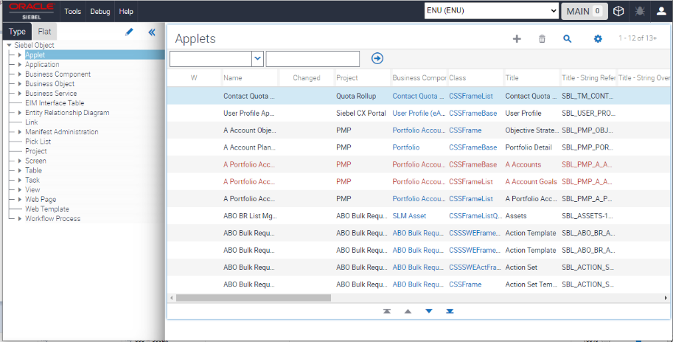

**Access Siebel Management Console**

1. To Access the Siebel Management Console, browse the link - https:<IP-address>:4430/Siebel/smc.
2. Enter the User ID as **SADMIN** and Password as **Welcome1** and click **Login** to login to the Siebel Management Console as shown below.

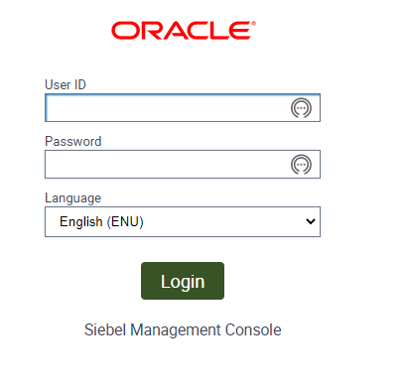

1. You have successfully logged into the Siebel Management Console as shown below.

